HD 65216A

HD 65216A is a 0.874 M☉, G5V star1. HD65216 is a triple star system with a projected separation of 253aubetween HD 65216A and the binary companion HD65216 B and C separated from each other by 6au2. The mass of HD65216 B (resp. C) is 0.089 (resp. 0.078) M☉. The CH survey reported a GP (HD 65216Ab) with a period of 579 days, a minimum mass of 1.41 MJup and an eccentricity of 0.26 as well as a LPGP (HD 65216Ac) with a period of 5542 days, a minimum mass of 2.24 MJup and an eccentricity of 0.15. Based on 52 RV CORALIE data obtained between 1999 and 2003 and 24 RV HARPS measurements obtained between 2003 and 2013, a study performed in 2019 (hereafter W19)3 reported properties of planets b and c close to those reported in the CH survey.

In the present study, the W19’s dataset was considered[1]. DPASS and MCMC (1000 walkers and 300000 iterations) were used to fit the data. The properties found for HD 65216Ab are close to those reported in the CH survey. For HD 65216Ac, properties close to those reported in the CH survey were found with DPASS and a period between 5800 and 28000 days, a minimum mass between 1.7 and 3.5 MJup and an eccentricity between 0.23 and 0.73 were found using MCMC. The poor sampling of the HARPS data does not constrain the period well.

To explore the range of possible values, the semi-major axis was fixed to different values and the data fitted with DPASS. *a* up to 45 au do not significantly change the rms of the residuals (6.8 m/s against 5.8 m/s with *a* left free). In this case (referred to as constrained *a*), the minimum mass is 2.2 MJup and the extremely high eccentricity is 0.9. As the RV curve of HD 65216Ac covers a maximum and a minimum, the stellar offset is well constrained and changing it will not change the possible values beyond those found with the constrained semi-major axis.

The fits are shown in Fig 1, and the corner plot in Fig 2, and the results summarized in Table 1.

Conclusion: The properties found in the CH survey for HD65216c are not confirmed. Additional data are needed to improve the long term coverage and sampling of the RV variations and further constrain the companion orbital properties.

Figure 1: Left: fit of the HD 65216A RV with DPASS. Red (resp. green) points correspond to the C98 (resp. H03) data. The blue curve shows the best fit. Middle: fit of the HD 65216A RV with DPASS, with the minimum *a* fixed at 45 au. The points are the same as on the left. The blue curve shows the best fit. The gray dotted line indicates the end of the CH survey. Right: fit of the HD 65216A RV using MCMC. The black curve shows the best fit. The colorbar corresponds to the log-likelihood of the fits. The gray dotted line indicates the end of the CH survey.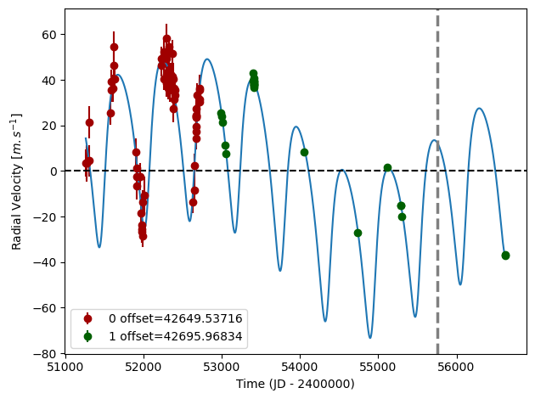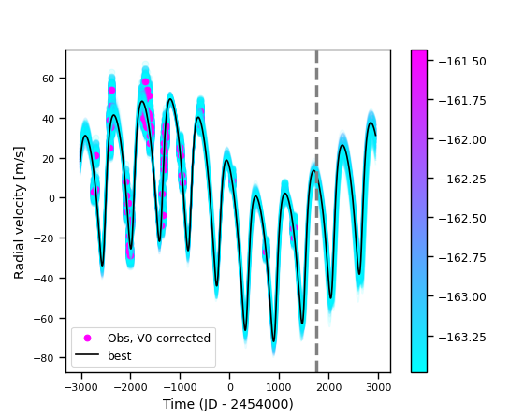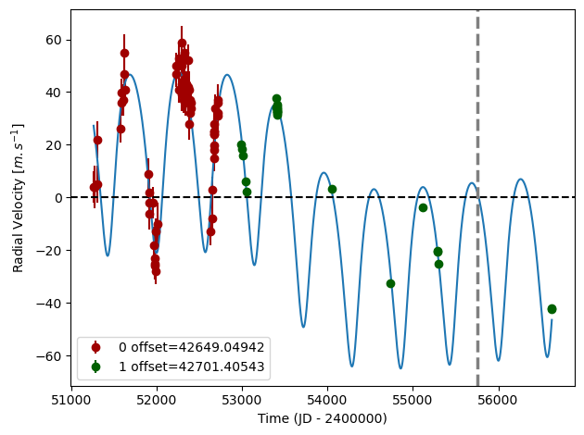

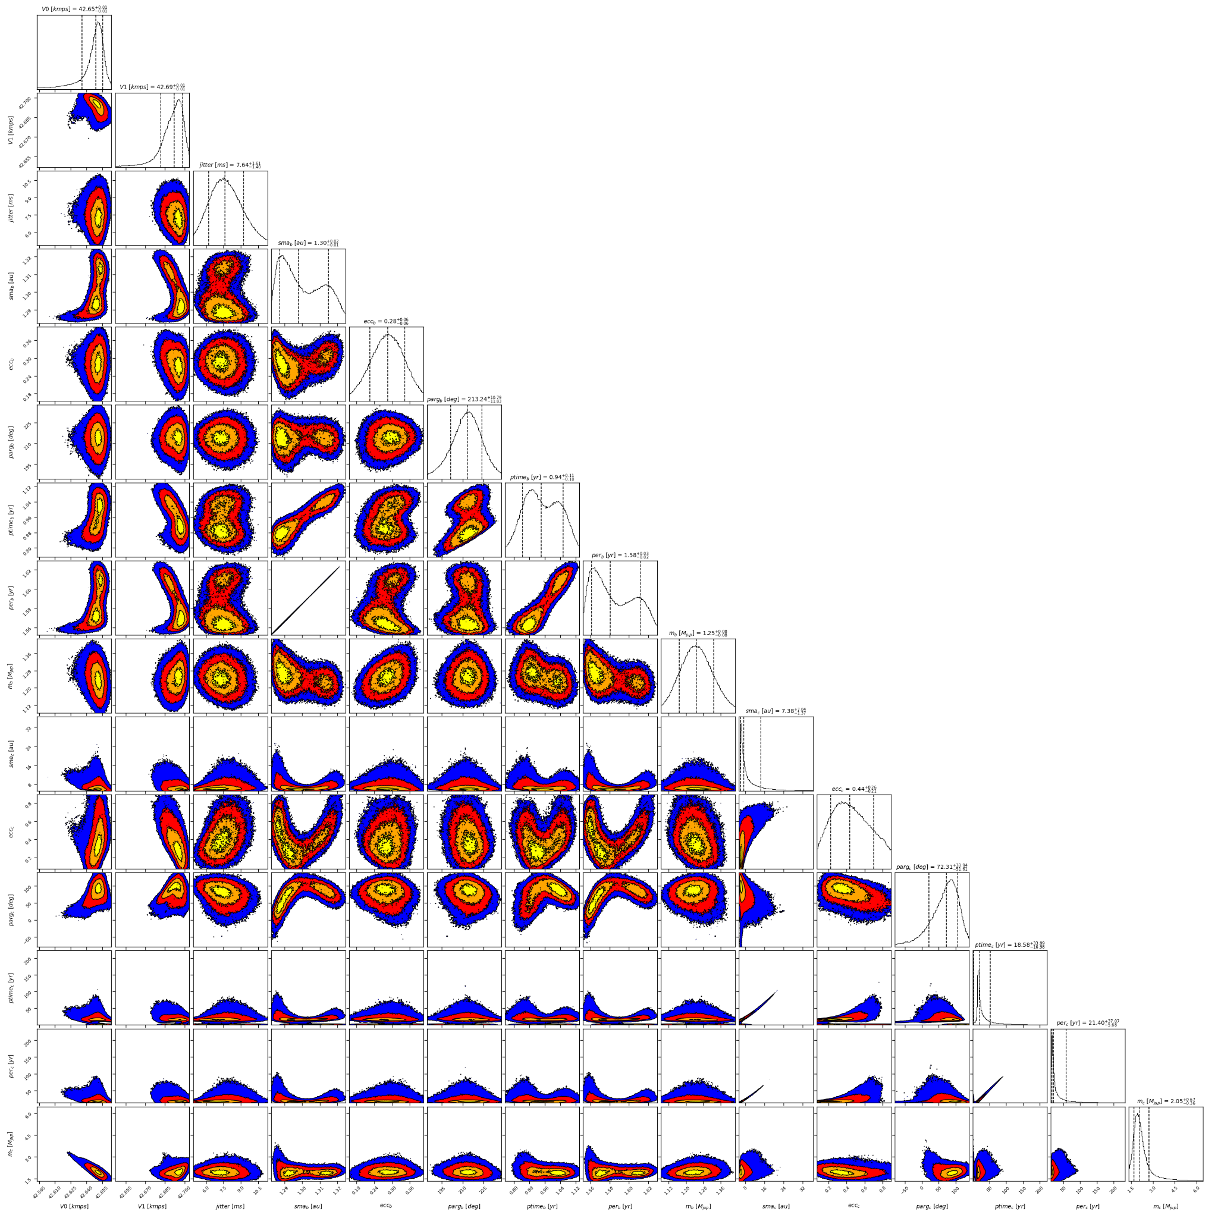

Figure 2: Corner plot of posteriors for the two-planets model MCMC fit of HD 65216A RV data.

| Parameter | Priors | | | Posteriors | | | CH survey |
| --- | --- | --- | --- | --- | --- | --- | --- |
|  | DPASS | | MCMC | DPASS | | MCMC |  |
|  | Free priors | Constrained *a* | Free priors | Free priors | Constrained *a* | Free priors |  |
| *a* (au) | b: [0,4]  c: [4,100] | b: [0,4]  c: up to 45 | b: [0.5,2]  c: [4,100] | b = 1.3  c = 5.8 | b = 1.3  c = 45 | b =  c = 6 – 17 | b = 1.3  c = 6 |
| Msin(i) (MJup) | b: [0,100]  c: [0,100] | b: [0,10]  c: [0,10] | b: [0.1,2]  c: [1,10] | b = 1.3  c = 2 | b = 1.24  c = 2.2 | b =  c = 1.7 – 3.5 | b = 1.41  c = 2.24 |
| Eccentricity | b: [0,0.95]  c: [0,0.95] | b: [0,0.95]  c: [0,0.95] | b: [0,0.95]  c: [0,0.95] | b = 0.17  c = 0.3 | b = 0.23  c = 0.9 | b =  c = 0.23 – 0.73 | b = 0.26  c = 0.15 |
| Instrumentals offsets (km/s) | [-100,100] | [-100,100] | [42,43] | C98: 42.650  H04: 42.696 | C98: 42.649  H04: 42.701 | C98: 42.627 – 42.656  H04: 42.678 – 42.698 |  |
| Stellar jitter (m/s) | [0,40] | [0,40] | [0,20] | 4.1 | 6.5 | 6.4 – 10.1 |  |
| Argument of periastron (°) | b: [0,360]  c: [0,360] | b: [0,360]  c: [0,360] | b: [0,360]  c: [0,360] | b = 214  c = 131 | b = 199  c = 94 | b =  c = 4 – 104 |  |
| Phase | b: [0,1]  c: [0,1] | b: [0,1]  c: [0,1] | b: [0,1]  c: [0,1] | b = 0.11  c = 0.08 | b = 0.83  c = 0.46 | b =  c = 0.93 – 0.16 |  |

Table 1: HD 65216A. Summary of priors and posteriors obtained with DPASS and MCMC, compared to the properties reported by the CH Survey.

References

1. Sousa, S. et al. Spectroscopic parameters for 451 stars in the HARPS GTO planet search program. Stellar [Fe/H] and the frequency of exo-Neptunes. *Astron. Astrophys*. 487, 373-381 (2008).
2. Mugrauer, M. et al. The multiplicity of planet host stars – new low-mass companions to planet host stars. *Mon. Not. R. Astron. Soc.* 378, 1328-1334 (2007).
3. Wittenmyer, R. et al. Truly eccentric - I. Revisiting eight single-eccentric planetary systems. *Mon. Not. R. Astron. Soc.* 484, 5859-5867 (2019).

1. The CORALIE data were not available on the CDS database; therefore, these data were recovered from DACE. Note that DACE provides in fact 70 measurements obtained with CORALIE, i.e 18 more than the data used by W193. Yet, the RV curve stays the same.